WanderLust - Shorthand

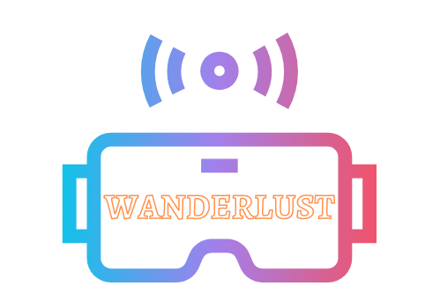 

VR Story Guide

## 

## Installation

In order to create the VR enhanced version of your story, extract your story in the desired directory, and then extract vrStoryEnhancement.zip into your primary story folder. Then enter your primary story folder, and then complete the following steps:

1. COPY FOLDER PATH
2. WINDOWS+R
3. “CMD” (enter)
4. “CD ” + CTRL+V (enter)
5. “node js_vr/masterFunction.js” (enter)

## Running the story

The story can now be run locally by right clicking on index.html. The normal story should appear here, but a new “Enter VR” button should have appeared at the top right. Clicking on this will take you to an guide page to navigate the VR story, and the button at the bottom will take you to the actual VR story. While this will not load any images due to the nature of the local server, once the website is hosted properly all media will load correctly. To view text in this moment, click the “vr” button at the bottom right of the screen.